Tab 1

Conservation of Momentum

Momentum is an important quantity because it is conserved. Yet it was not conserved in the examples like hitting a baseball with a bat, where large changes in momentum were produced by forces acting on the baseball. Under what circumstances is momentum conserved?

Answer: Momentum of an isolated system is conserved when the net force exerted on the system is zero.

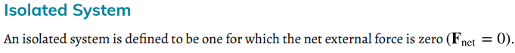
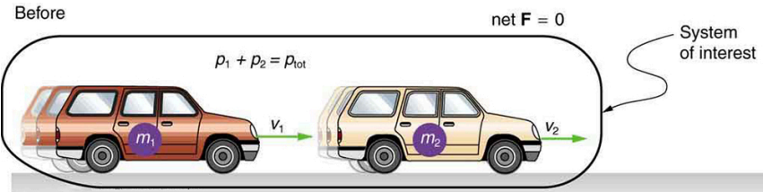
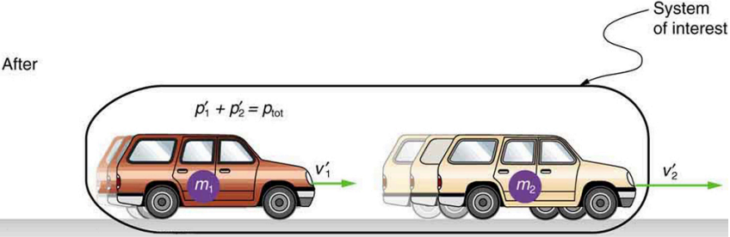

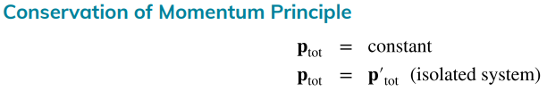
Total momentum before = Total momentum after, or $p_{i}=$$p_{f}$

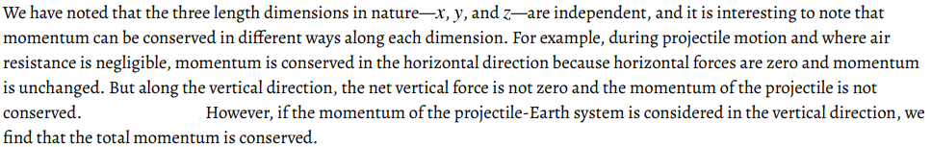

Collision 1D (Conservation of Momentum)
$P_{i}=P_{f}$ or $m_{1}v_{01}+m_{2}v_{02}=m_{1}v_{f1}+m_{2}v_{f2}$
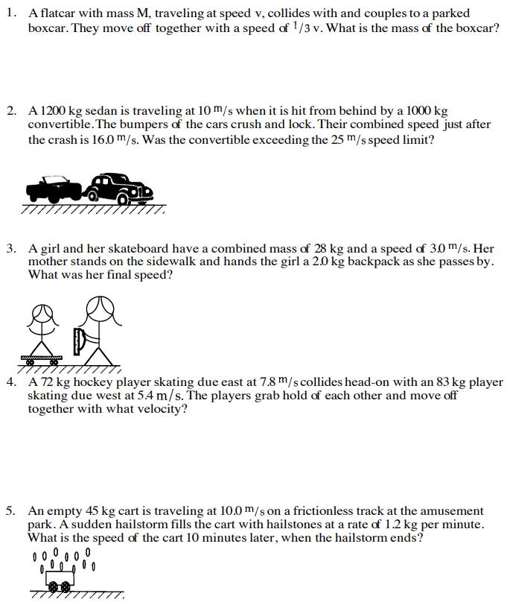

Collision 1D (Continued)
Conservation of Momentum:$P_{i}=P_{f}$ or $m_{1}v_{01}+m_{2}v_{02}=m_{1}v_{f1}+m_{2}v_{f2}$
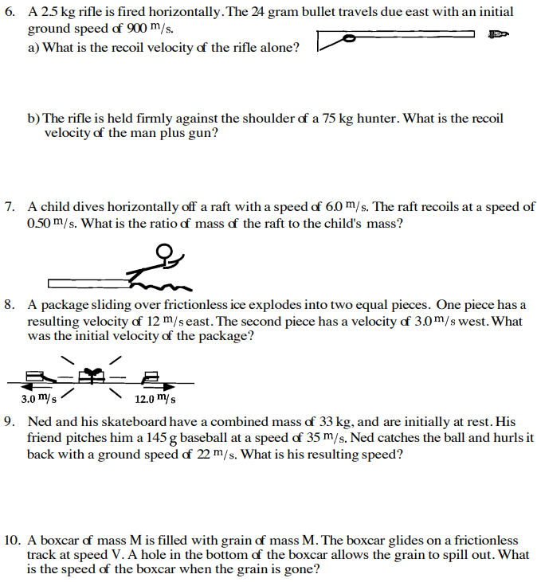

Lab: Verify Conservation of Momentum using Horizontal Projectiles
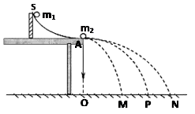
Objectives: Verify Conservation of Momentum using Horizontal Projectiles
Lab Materials: Ramp, one ball with a larger mass, the other ball with a smaller mass, metersticks, scale.

Procedure:
1. Place ball 1 at point S and ball 2 at point A
2. Mass ball 1and ball 2 : $m_{1}$= _________ $m_{2}$= ____________
3. Release ball 1 at Point S from rest, let it collide with ball 2 at point A
4. Mark the positions of ball 1 and 2 when they hit the ground, M and P
5. Measure the height of S above the table top $h$
6. Measure the height of the table $H_{}=AO$ , measure the horizontal distance on the ground OM and OP
7. Set the ball 1 at a different position on the ramp. Repeat steps 3-6

Data:
 | $h$ | $v_{01}=\sqrt{2gh}$ | $v_{02}$ | $H$ | $t=\sqrt{\frac{2H}{g}}$ | $x_{1}$ | $x_{2}$ | $v_{f1}=\frac{x_{1}}{t}$ | $v_{f2}=\frac{x_{2}}{t}$
1
2
3

 | Momentum before Collision $P_{i} =m_{1}v_{01}+m_{2}v_{02}$ | Momentum after Collision $P_{f} ={m_{1}v_{f1}+ m_{2}v_{f2}}^{}$ | Percent Difference $\frac{P_{i} - P_{f}}{P_{i}}×100\%^{}$ | ${ P}_{i }=P_{f } ?$
1
2
3

Tab 2

